Annex 1.A.1
Ambulance Patient Trolley Bed with Adjustable base

- Function:

- Aluminum Alloy Structure, which is lightweight, has good toughness, and has easy disinfection function.
- Sponge Cushions and Adjustable Backrest Angles
- This patient trolley bed has 3 heights that can be adjusted in the ambulance.
- This stretcher car adopts a folding leg mechanical structure, and the folding is controlled by the right-hand handle, only Need an ambulance person to push the patient into the ambulance.
- Rubber material of the wheel of this stretcher car is durable and stable.
- After being stretched, the stretcher must be locked with the fixing device on the ambulance to ensure the safety of the patient during the operation of the ambulance.
- This stretcher is equipped with two safety straps to ensure the safety of the patient.
- When the patient arrives at the ward or destination, open the rear fixed lock and slowly pull it down from the ambulance. The stretcher leg will be automatically lowered.
- The trolly bed will be used for the ambulance vehicle type Nissan - Urvan.
- To ensure a matching set, an adjustable base should accompany a trolly bed. The base should be fit to Nissan / Urvan.

- Specifications:

- Size:190*55*92cm
- Folded Size:190*55*25cm
- N.W.: 40kg
- G.W.:46kg
- Capacity:159kg
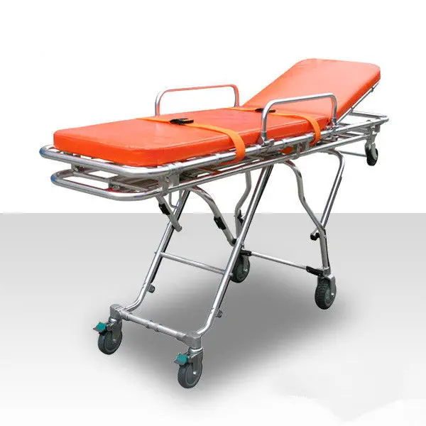

For Example:
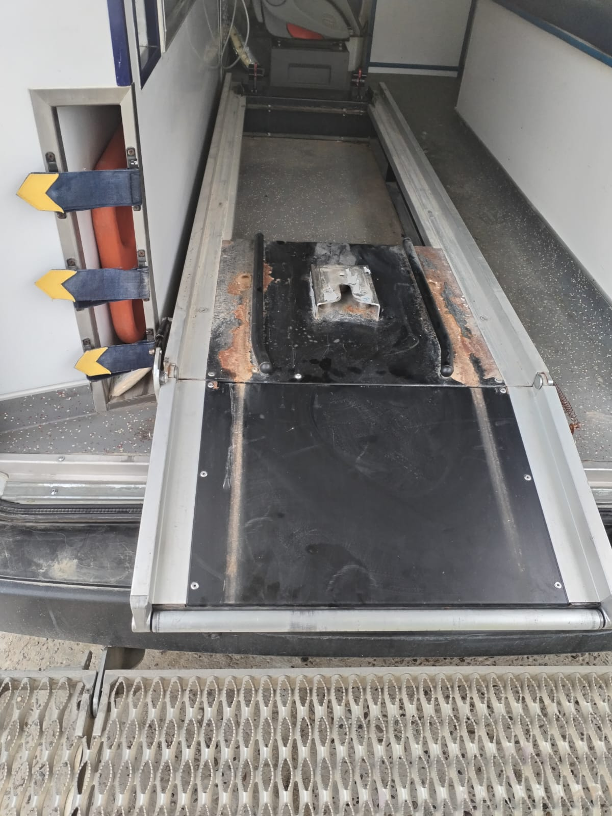
The base of vehicle
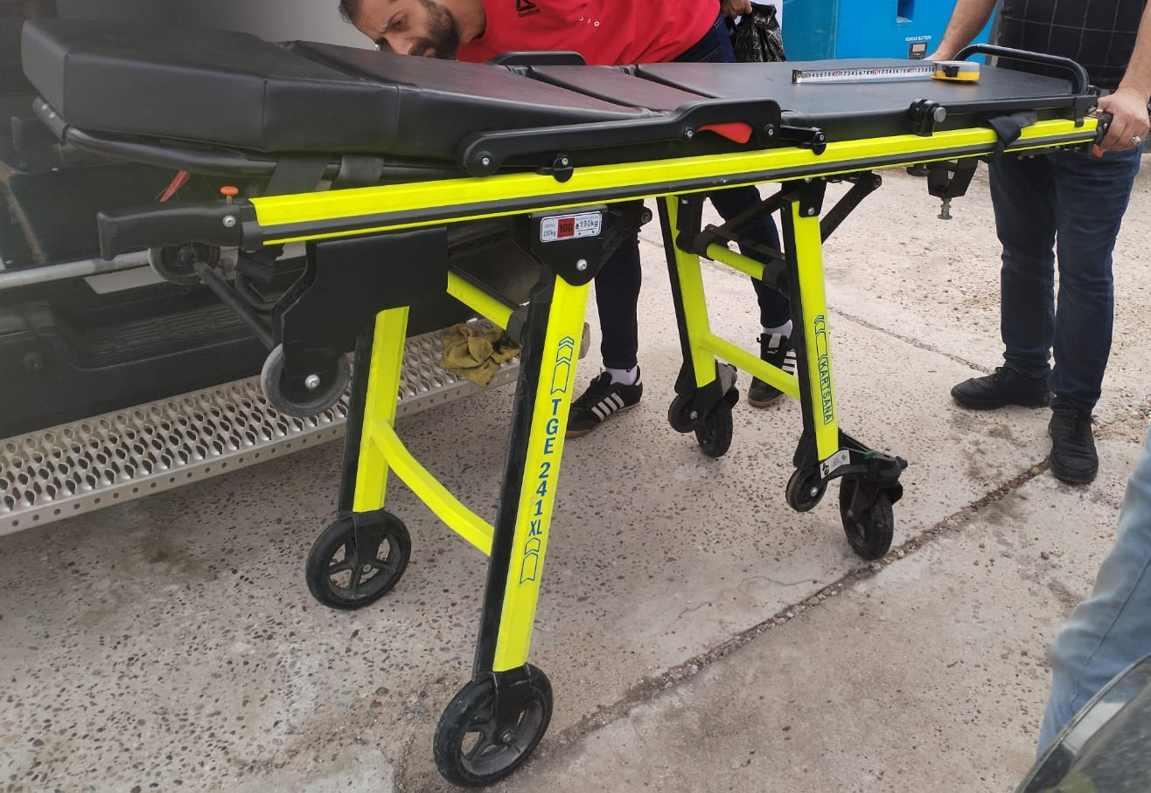
Old trolly bed

